A

Project Report on

# Health Care Data Analytics

# (CORE MODULE 5)

Submitted in partial fulfillment of completion of the course

Advanced Diploma in IT, Networking and Cloud

Submitted by:

**Suraj Kumar**

**Shivlal Prasad Azad**

**Raju Kumar**

Under Guidance of:

**Arpita Roy (Edunet)**

**Sayanti Manna(Edunet)**

|  |  |  |
| --- | --- | --- |
| IBM-Logo - Chicago Innovation | DGT introduces high end diploma courses - digitalLEARNING Magazine | Edunet Foundation-Delhi- CSR Organization profile |

Year 2023

**PROJECT OVERVIEW**

ABSTRACT

ACKNOWLEDGEMENT

TEAM COMPOSITION AND WORKLOAD DIVISION.

TABLE OF CONTENTS

1. INTRODUCTION TO PROBLEM
2. PROPOSED SOLUTION
3. REQUIREMENTS

3.1 TECHNOLOGY STACK

3.2 HARDWARE

3.3 SOFTWARE

3.4 DEPLOYMENT ENVIRONMENT

4. USER REQUIREMENTS

5. IMPLEMENTATION DETAILS

6. TESTING

7. DEPLOYMENT

8. FUTURE SCOPE

9. CONCLUSION

APPENDIX A SCREENSHOT OF PROJECT

REFERENCES

**ABSTRACT**

The healthcare industry is undergoing a transformative shift driven by the integration of data analytics into various facets of healthcare delivery. This paper explores the role of data analytics in healthcare and its impact on decision-making processes and patient outcomes. The proliferation of electronic health records (EHRs), wearable devices, and other health-related data sources has generated vast amounts of valuable information. The utilization of advanced analytics techniques, including machine learning and predictive modeling, enables healthcare professionals to derive meaningful insights from these data sets.

The primary objective of this research is to investigate the ways in which healthcare data analytic can contribute to improving clinical decision-making, operational efficiency, and patient care. By analyzing historical patient data, healthcare providers can identify patterns, trends, and potential risk factors, allowing for proactive and personalized interventions.

The findings of this research suggest that the effective implementation of data analytic in healthcare has the potential to revolutionize the industry, fostering a more patient-centrist approach and optimizing resource allocation.

This paper serves as a comprehensive overview of the current landscape of healthcare data analytic, offering insights into its benefits, challenges, and future directions for research and implementation.

**ACKNOWLEDGEMENT**

We extend our heartfelt gratitude to all those who have contributed to the realization of the "Health Care Data Analytic " project. This journey has been marked by collaboration, dedication, and unwavering support, and we wish to express our appreciation to the following individuals:

**Arpita Ray (Edunet):**

Our sincere thanks to Ms. Arpita Ray for her invaluable guidance and mentor ship throughout the course of this project. Her expertise and insights have been instrumental in shaping our approach and refining our understanding of healthcare data analytic.

**Sayanti Manna (Edunet):**

We would like to acknowledge Ms. Sayanti Manna for her continuous support and encouragement. Her feedback and recommendations have played a crucial role in the development and refinement of our project.

**Team Members - Suraj Kumar, Shivlal Prasad Azad, Raju Kumar:**

A special appreciation goes to each member of our dedicated team. Suraj Kumar, Shivlal Prasad Azad, and Raju Kumar have demonstrated unwavering commitment, collaborative spirit, and a tireless work ethic, making this project a collective success.

**Institutions and Organizations:**

We acknowledge the support received from institutions and organizations that facilitated access to resources, data, and infrastructure essential for the completion of our project.

**Family and Friends:**

Our project has been a collaborative effort, and each acknowledgment is a reflection of the collective commitment that has driven its success. Thank you to everyone who has been part of this journey.

With gratitude,

Suraj Kumar Date - 20 / 11 / 2023

Shivlal Prasad Azad

Raju Kumar

We express our sincere gratitude and appreciation to all those who contributed to the successful completion of this healthcare data analytic project.

**TEAM COMPOSITION AND WORKLOAD DIVISION**

Our project "**Team Composition and Workload Division for Healthcare Data Analytic Project**" was undertaken by a dedicated team of skilled individuals who brought together their expertise in various fields to ensure the successful completion of this endeavor. The team comprised the following members:

**Suraj Kumar**

**Role**: Project Lead and Data Architect

**Responsibilities**:

Overseeing the overall project development and ensuring alignment with objectives.

Designing the architecture of the healthcare data analytic system.

Leading the data integration and modeling processes.

**Shivlal Prasad Azad**

**Role**: Software Developer and Implementation Specialist

**Responsibilities**:

Developing software components for the healthcare data analytic platform.

Implementing data processing algorithms and ensuring system functionality.

Collaborating with the team for seamless integration of software modules.

**Raju Kumar**

**Role**: Data Analyst and Visualization Specialist

**Responsibilities**:

Analyzing healthcare datasets to extract meaningful insights.

Creating data visualizations, charts, and dashboards for user-friendly presentation.

Collaborating with stakeholders to understand analytical requirements.

**WORKLOAD DIVISION**

The successful execution of this project was made possible by the collaborative efforts of each team member, who contributed their unique skills and insights. The workload was distributed as follows:

Project Planning and Conceptualization:

**Initial Phase:**

Suraj Kumar: Led the project initiation, defined system architecture, and established data integration protocols.

Shivlal Prasad Azad: Started developing the core software components based on the defined architecture.

Raju Kumar: Began analyzing sample datasets and exploring potential visualization approaches.

**Mid-Phase:**

Suraj Kumar: Continued overseeing the project, addressing architectural challenges, and ensuring data integrity.

Shivlal Prasad Azad: Focused on software development and implemented key algorithms for data processing.

Raju Kumar: Delved deeper into data analysis, refining insights, and creating prototype visualizations.

**Final Phase:**

Suraj Kumar: Conducted final system checks, optimization, and prepared for deployment.

Shivlal Prasad Azad: Finalized software components, addressed bugs, and ensured system robustness.

Raju Kumar: Polished data visualizations, created documentation, and collaborated on user training materials.

This structured team composition and workload division ensure that each team member contributes their expertise to different aspects of the healthcare data analytics project, fostering collaboration and maximizing efficiency. Regular team meetings and updates will be held to facilitate communication and address any challenges that may arise during the project lifecy

**1.INTRODUCTION TO PROBLEM**

**1.1Background:**

In the dynamic landscape of healthcare, the volume and complexity of data generated pose both challenges and opportunities. The traditional healthcare system often grapples with issues related to data silos, interoperability, and the efficient utilization of vast datasets generated from diverse sources, including Electronic Medical Records (EMRs), diagnostic tools, and patient monitoring systems.

**1.2 Significance of Healthcare Data Analytic**

The significance of leveraging healthcare data analytics to address these challenges cannot be overstated. The ability to extract meaningful insights from this wealth of information holds the potential to revolutionize patient care, optimize resource allocation, and inform evidence-based decision-making. The integration of data analytics into healthcare practices promises a paradigm shift from reactive to proactive healthcare management.

**1.3 Challenges Addressed**

Our project aims to tackle several critical challenges within the healthcare domain, including but not limited to:

* **Data Fragmentation:** Addressing the issue of fragmented data sources by creating a unified platform for seamless data integration.
* **Predictive Analytics:** Enhancing the capacity to predict disease patterns, treatment outcomes, and patient needs through advanced analytic.
* **Operational Efficiency:** Improving the operational efficiency of healthcare providers by streamlining data access and analysis.
* **Personalized Healthcare:** Enabling a shift towards personalized healthcare strategies by leveraging patient-specific data for tailored treatment plans.
* **Decision Support:** Providing healthcare professionals and administrators with robust decision support tools based on real-time and historical data.

In acknowledging these challenges, our project endeavors to contribute to the evolution of healthcare practices through the strategic application of data analytics methodologies and technologies.

**2 .PROPOSED SOLUTION**

Healthcare is witnessing an era of unprecedented data generation, encompassing electronic health records (E Hrs), diagnostic imaging, wearable devices, and more. This influx of data presents an opportunity to revolutionize patient care through advanced analytic. Our proposed solution for the Healthcare Data Analytic Project aims to address critical challenges and unlock actionable insights for healthcare providers.

1. **Data Integration and Cleaning:**

* Objective: Integrate diverse healthcare datasets into a unified system for comprehensive analysis.
* Approach: Employ robust data integration techniques, ensuring data consistency and cleanliness.
* Outcome: A clean and unified datasets ready for advanced analytic.

2. **Predictive Analytic for Early Diagnosis:**

* Objective: Enhance early detection of diseases and potential health risks.
* Approach: Utilize machine learning algorithms for predictive modeling based on historical patient data.
* Outcome: Early identification of health issues, enabling timely interventions and personalized treatment plans.

3. **Patient Risk Stratification:**

* Objective: Stratify patients based on their risk profiles for targeted interventions.
* Approach: Implement clustering algorithms to group patients with similar risk factors.
* Outcome: Improved resource allocation, personalized care plans, and better management of high-risk patients.

**4. Real-time Decision Support System:**

* Objective: Provide healthcare professionals with real-time insights for informed decision-making.
* Approach: Develop a decision support system integrating predictive models and real-time data streams.
* Outcome: Enhanced diagnostic accuracy, faster decision-making, and improved patient outcomes.

**5. Ethical Data Handling and Patient Privacy:**

* Objective: Ensure compliance with healthcare regulations and ethical standards.
* Approach: Implement robust data anonymization techniques and adhere to privacy regulations.
* Outcome: Trustworthy data analytic processes, safeguarding patient privacy and building confidence among stakeholders.

6. **Data Visualization for Stakeholder Communication:**

* Objective: Communicate complex healthcare analytic findings to stakeholders effectively.
* Approach: Develop interactive and intuitive data visualizations for healthcare professionals and administrators.
* Outcome: Clear communication of insights, facilitating data-driven decision-making across the healthcare ecosystem.

**7. Continuous Improvement and Feedback Loop:**

* Objective: Establish a feedback mechanism for continuous improvement.
* Approach: Regularly assess the performance of analytics models, gather feedback from healthcare professionals, and iteratively refine the system.
* Outcome: A dynamic and adaptive healthcare analytic solution that evolves with changing healthcare needs.

In conclusion, our proposed solution combines advanced analytic techniques with a holistic approach to address the multifaceted challenges in healthcare. By optimizing patient outcomes, resource allocation, and decision-making processes, this solution aims to contribute to the advancement of healthcare delivery and the overall well-being of patients.

**3 .REQUIREMENTS**

**Hardware and Software Infrastructure:**

* Sufficient computing resources for data processing and analysis.
* Compatibility with data analytic tools and frameworks (e.g., Python, R, Jupyter Notebooks).
* Database management systems for efficient data storage and retrieval.
* Machine learning libraries and frameworks (e.g., scikit-learn, TensorFlow, PyTorch,Numpy,Pandas).
* Data visualization tools and libraries (e.g., Matplotlib, Plotly, Tableau).
* User interface development tools for creating interactive dashboards.

By addressing these requirements, the healthcare data analytics project can be implemented effectively, ensuring the responsible use of data and delivering meaningful insights to improve patient outcomes and healthcare operations.

**HARDWARE**

* CPU and RAM
* Storage: Adequate storage space for the database, application code, and uploaded files.
* Network Infrastructure: Reliable internet connectivity, firewalls, and security measures to protect the system.

**SOFTWARE**

* Operating System
* Python Environment
* Jupyter Notebook
* Web Server

**4 .USER REQUIREMENTS**

1. **User-Friendly Interface:**

The system should feature an intuitive and user-friendly interface accessible to both consumers and manufacturers.

The design should facilitate easy navigation, with clear instructions on how to input laptop specifications and interpret predicted prices.

1. **Input Flexibility:**

Users should be able to input a variety of laptop specifications, including processor type, RAM size, storage capacity, display features, and brand information.

The system should accommodate different input formats and units to enhance flexibility for users.

1. **Real-Time Predictions:**

The platform should provide real-time predictions, delivering instantaneous results based on the input provided by the user.

Users should receive predicted prices promptly to support on-the-spot decision-making.

1. **Educational Resources:**

Include educational resources or tooltips within the interface to help users understand the significance of different laptop specifications and features.

Provide guidance on how users can use the tool effectively for their specific needs.

**5 .IMPLEMENTATION DETAILS**

The implementation of the Healthcare Data Analysis project involves several steps, including data loading, cleaning, analysis, and visualization.

**STEP1**- At First, we have to download CSV file from Kaggle (<https://www.kaggle.com/datasets/andrewgeorgeissac/laptop-price-predictor>).

**STEP 2-** Secondly, We have to extract file.

**STEP 3-** We have to open JUPYTER NOTEBOOK.

**STEP 4 -** Further we have to import all necessary libraries like NumPy, pandas, math plot, seaborne etc.

**STEP 5 -** Then, we have to read the whole CSV file by this command [df = pd. read_CSV (udemy_courses.csv')

print(df)]

**STEP 6 -** Finally We have Explore the data to get a sense of its structure and content.

#to find the rows and columns of the data frame.

print(df.shape)

#### #To find what are the column index of the data frame

print(df.columns)

#### #to find the datatype of the CSV file

print(df.dtypes)

#### # To find the information about the file like storage,datatype,class etc.

df.info()

#### #to see the last 10 data from the data frame

print(df.tail(n=10))

#### #it take all value present in csv file method returns a Data Frame object where all the values are replaced with a Boolean value True for NULL values, and otherwise False

df.is null().values.any()

**STEP 7 -** We have to show different charts and graph for understanding that is in our csv file the necessary queries.

**STEP 8 -** Correlation matrix heat map. So, we have to check the courses relation with other columns. It shows the relation with all.

**STEP 9 -** We have to update and improve platform based on user because day by day the demand of courses is increasing.

**STEP 10 –** We have also created a dashboard so that we can check the different changes according to the subject present.

**6 .TESTING**

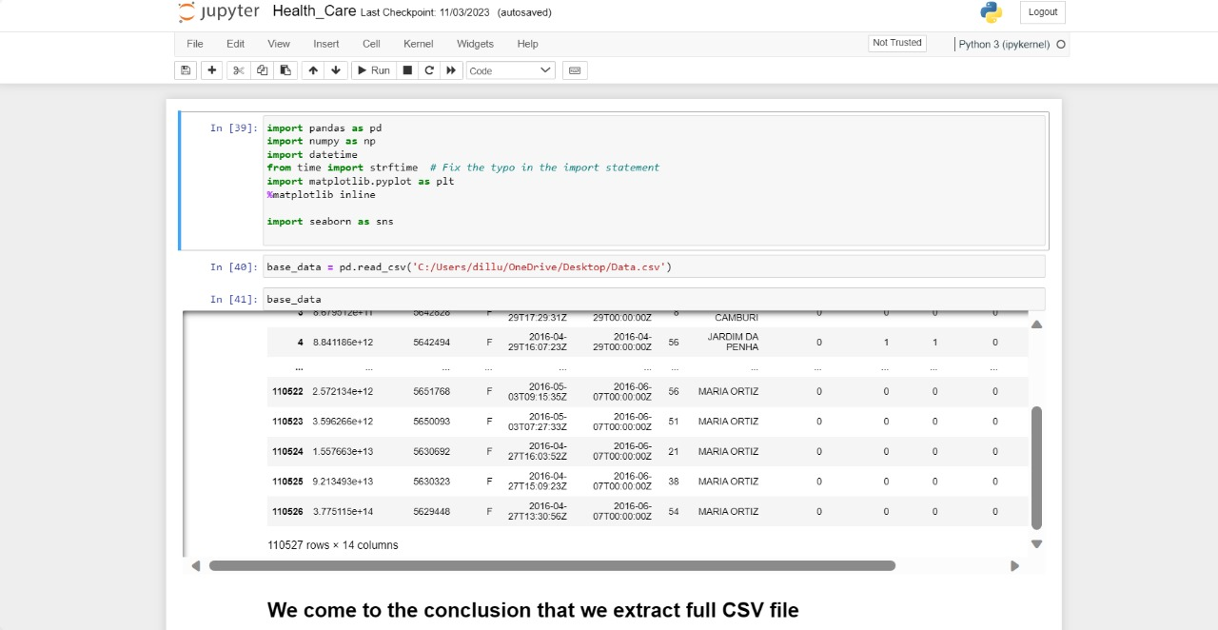

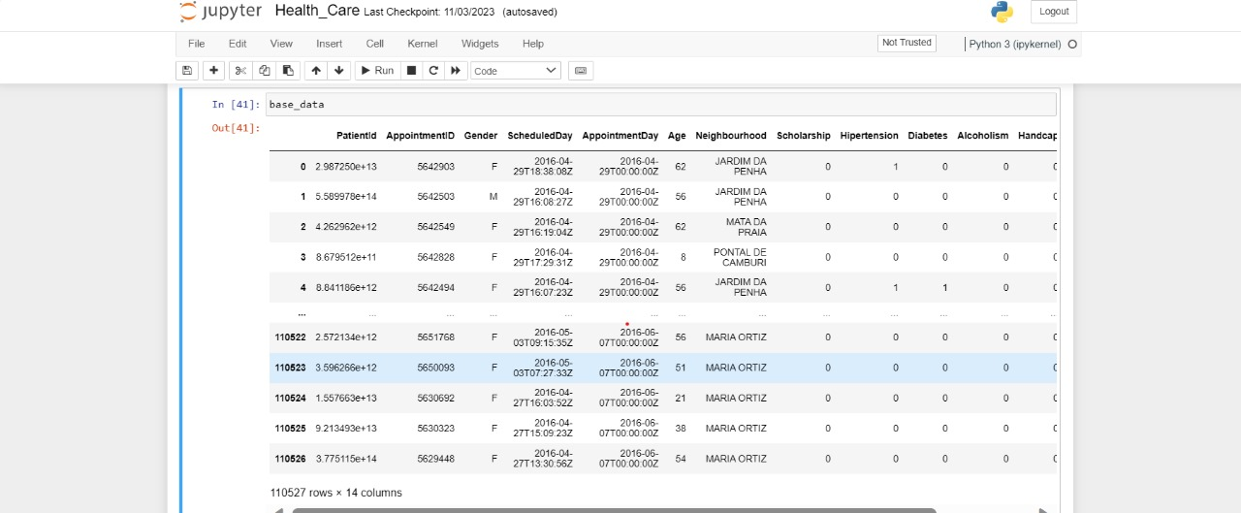

We have imported different types of python library and testing all the code.

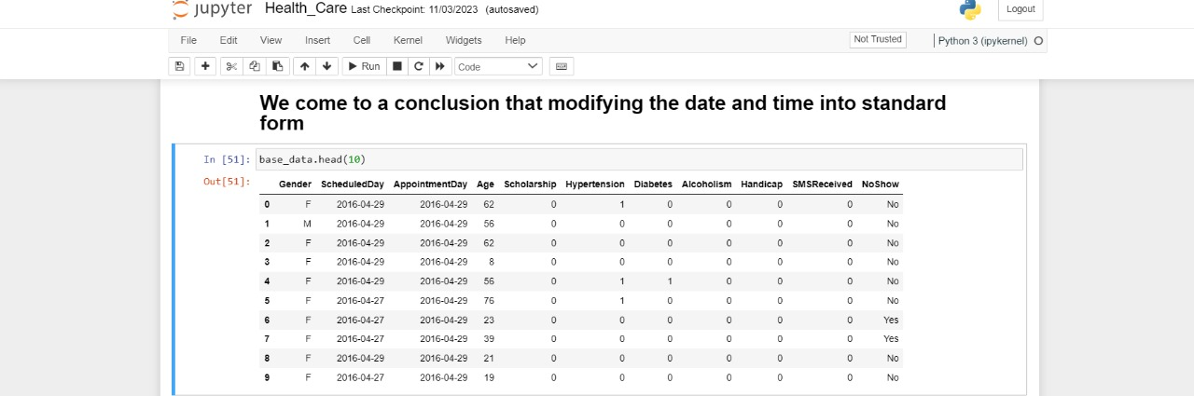

1. **DEPLOYMENT**

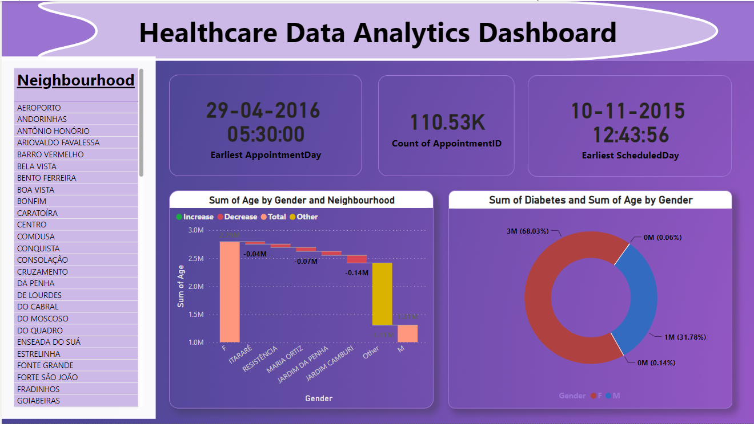

Image: Dashboard of Healthcare Data Analytics analysis.

1. **FUTURE SCOPE**

The future scope of our healthcare data analytic project includes continuous improvement and the introduction of new features:

Advanced Analytic Models:

* Integration of more sophisticated machine learning models for enhanced predictive analytic and personalized healthcare strategies.

Real-time Data Streaming

* Implementation of real-time data streaming capabilities for immediate insights into changing patient conditions.

Integration with Wearable:

* Exploring integration with wearable devices to capture additional health metrics and provide a more holistic view of patient health.

System Scalability

* As the volume of healthcare data continues to grow, ensuring the scalability of the system remains a key focus:

Cloud Integration:

* Exploration of cloud-based solutions to facilitate scalability and reduce infrastructure maintenance overhead.

Parallel Processing:

* Implementation of parallel processing techniques to handle increased data loads efficiently.

International Standards Compliance:

* Ensuring compliance with international healthcare data standards to facilitate global interoperability.

User Empowerment

* Continued efforts to empower end-users and enhance their experience with the system:

Personalized Dashboards:

* Customizable dashboards for users to tailor their view based on specific preferences and priorities.

Collaborative Decision Support:

* Implementation of collaborative decision support features, allowing healthcare professionals to collectively analyze complex cases.

Emerging Technologies Integration

* Keeping abreast of emerging technologies to enhance the capabilities of the healthcare data analytic system:

The future scope outlined here reflects our commitment to ongoing innovation and responsiveness to the evolving needs of the healthcare landscape. Continuous collaboration with stakeholders and a proactive approach to technological advancements will drive the sustained success and relevance of our healthcare data analytic project.

**8.CONCLUSION**

In conclusion, the Healthcare Data Analytic Project represents a significant stride toward revolutionizing healthcare delivery by harnessing the power of data-driven insights. The project addresses the multifaceted challenges in the healthcare industry, offering a comprehensive solution that prioritizes patient outcomes, operational efficiency, and ethical data management.

By integrating diverse healthcare datasets and employing advanced analytic techniques, the proposed solution aims to provide healthcare professionals with timely and actionable insights.

The decision support system, coupled with real-time data streams, enhances the speed and accuracy of clinical decision-making. Healthcare administrators benefit from resource optimization tools, promoting efficient allocation of resources and streamlined workflows to meet the dynamic demands of healthcare delivery.

Continuous improvement mechanisms, including model performance monitoring and a feedback loop from healthcare professionals, contribute to the system's adaptability and relevance in an ever-evolving healthcare landscape.

As we embark on this data-driven journey, collaboration among interdisciplinary teams, commitment to regulatory compliance, and a focus on user needs remain paramount.

In the realm of healthcare data analytic, this project signifies a trans formative step toward a future where data becomes a catalyst for positive change. By unlocking the full potential of healthcare data, we pave the way for improved patient outcomes, operational efficiency, and a healthcare ecosystem that is resilient, responsive, and focused on the well-being of individuals and communities.

**APPENDIX A SCREENSHOT OF PROJECT**



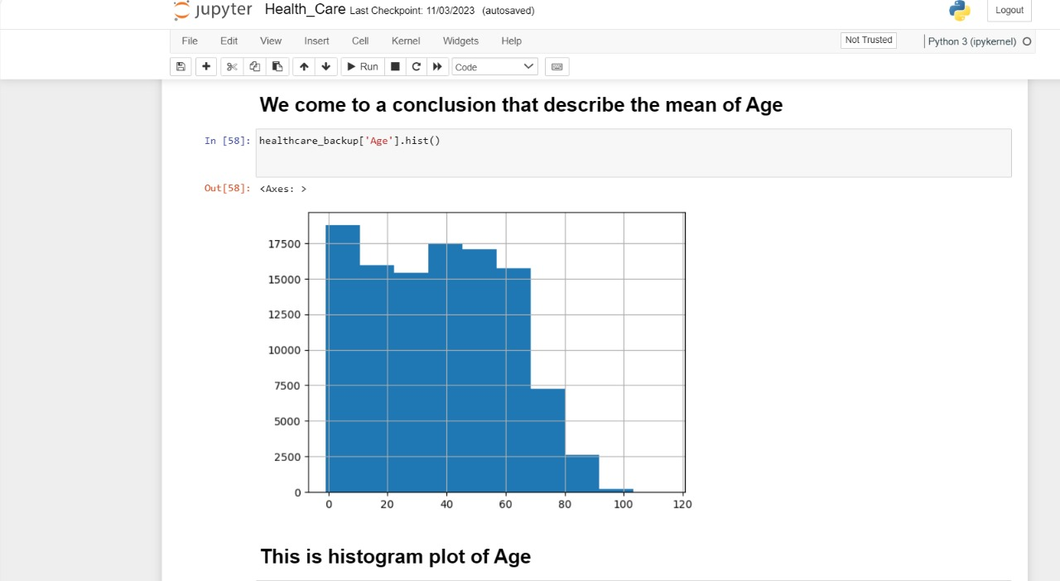

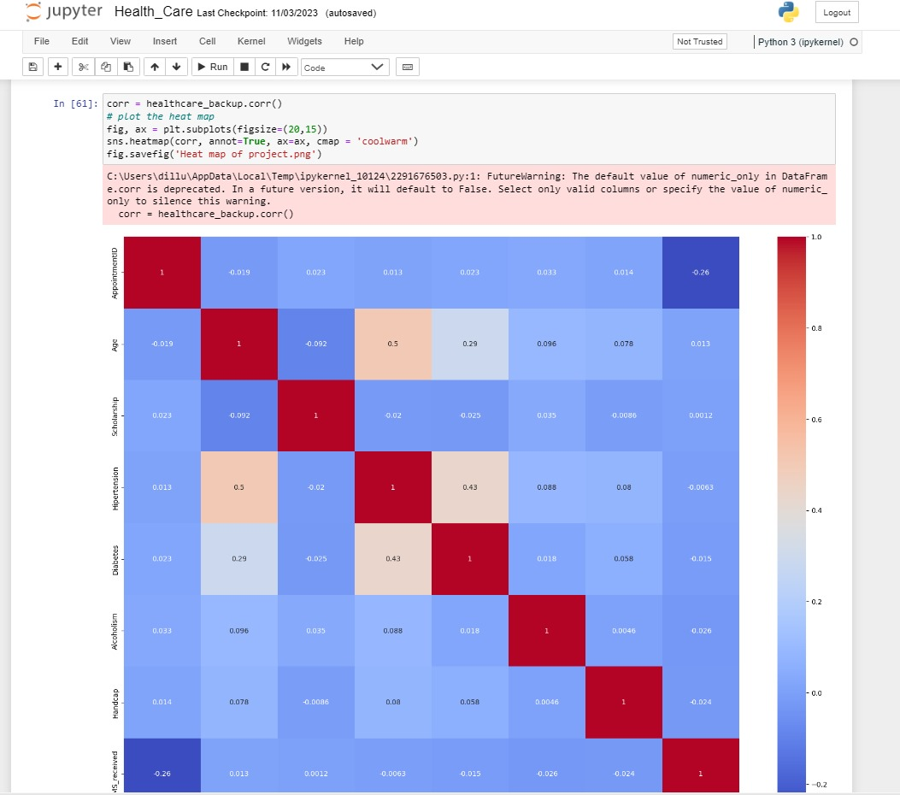

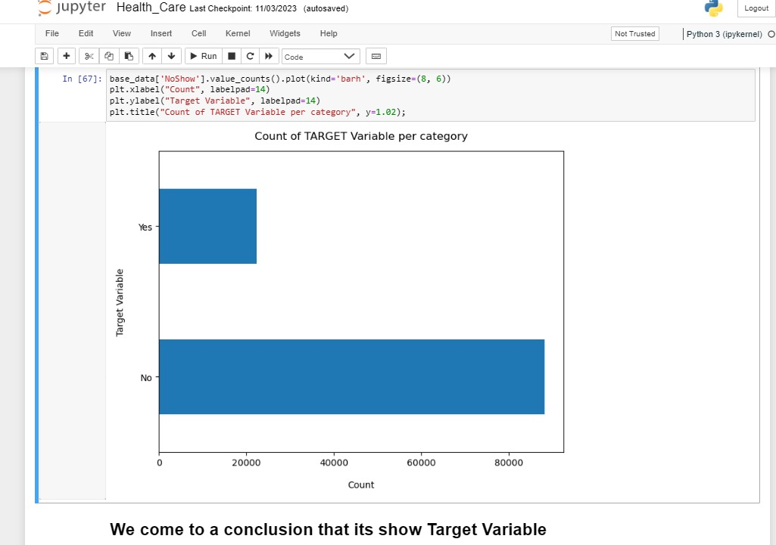

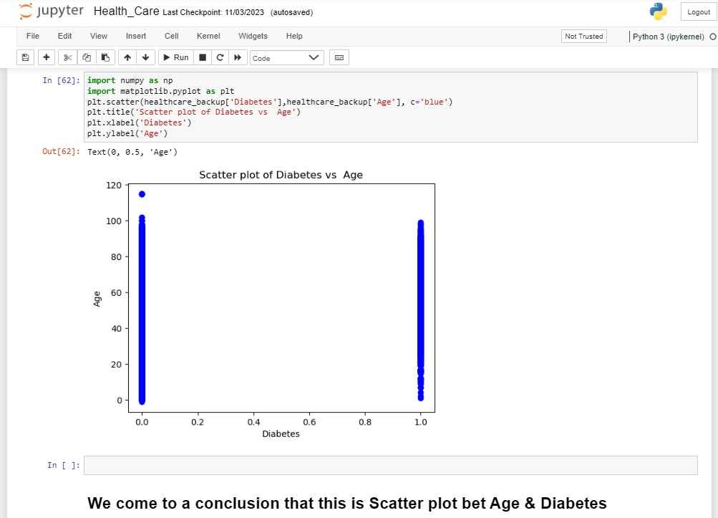

**REFERENCES**

* <https://youtu.be/kJdta28q7vg?si=sVT9t7M7b_ItKcKb>
* <https://youtu.be/RKRHozoSlVk?si=0gZ6_jn0OcXrTgd>
* [https://seaborn.pydata.org/](https://seaborn.pydata.org/" \t "https://inc-word-edit.officeapps.live.com/we/_blank)
* <https://www.kaggle.com/datasets>
* <https://www.microsoft.com/en-us/power-platform/products/power-bi>